Unit of Work:

Our business logic will likely need to access a few DB tables. But would like to write unit tests for the business logic.

Can use **Unit of Work** and the **Repository pattern**.

Repo pattern:

* Create a generic Irepository interface, one table will map to exactly one repository.
* Create a IunitOfWork interface, which is capable of returning a repository for a table, and takes care of commiting changes to the database.
* Create concrete implementations of those interfaces.

Business logic:

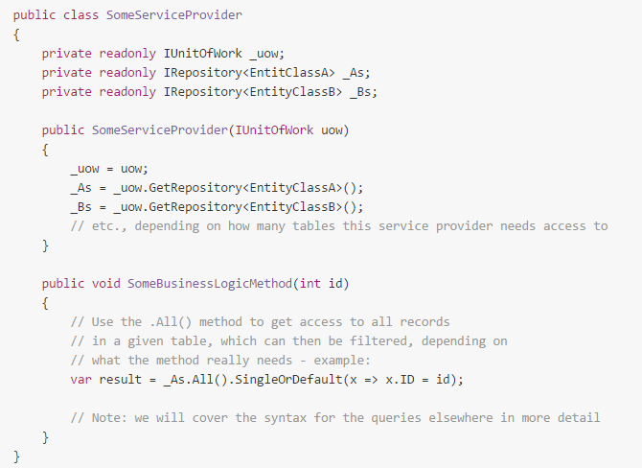UoW through constructor param, stores that reference.. (dependency injection).

UoW object **QUERIES FOR REPOSITORIES**..